


Windows Golden Image SOP

Index

Purpose: 1
Overview: 1
Steps: 2
QC / Validation: 2
Escalation Matrix: 2

Version Control:

Date | Author | Reviewer | Version | Updated Sections
07/15/2018 | HCL CloudOps | Rogers FTE | 1.0 | Initial Draft
08/03/2018 | HCL CloudOps | Rogers FTE | 1.1 | Updated sections

Purpose:

The purpose of this document is to provide step by step migration of on-premise golden image to Microsoft Azure.

By using on-premises Windows Server licenses that include Software Assurance to save big on Windows Server VMs in Azure. By using your existing licenses, you pay the base compute rate and save up to 40 percent.

Steps:

Migrating Golden Image From VMware to Microsoft Azure

Before you upload a window virtual machine (VM) from on-premise to Microsoft Azure, you must complete below checklist.

- Ensure you are using Windows Server 2012 R2 Edition
- All latest patches must be installed
- Security Account must be created
- Rename Administrator account to John Smith and Create dummy account called Administrator and disable it.
- Install OMS Agent
- Disable windows update service once all the patches are installed
- Set Windows configurations for Azure
- Sysprep Windows Server 2012 R2
- Convert VMDK to VHD
- Upload VHD to storage account
- Create image and add vhd file to images.
- Create a VM from a Golden Image

- Windows Server Version
As per Rogers standard and CAF, we will be using Windows Server 2012 R2 edition on Azure.

- Make sure all the latest patches are installed on the server.
On a Windows 2012 R2 server press the Windows key and type Control Panel. If necessary, switch the View by: settings to Small Icons and click Windows Update.
- Click Check online for updates from Microsoft Update.
- Click on the Install now button.

- Create a security account for Window

Create a local account ‘serv_tvm_local’
- Member Of: Local Administrators
- First Name: serv_
- Last Name: tvm_local
- Display Name: serv_tvm_local
- Description: Application ID for TVM Qualys – Daniel De Groot
- Account Options: ‘password never expires’
- Password: create complex password > password length is greater 14 characters

  - Configure Local Security Policy
Under Local Policies/User Rights Assignments:
- Deny log on as a batch job – add serv_tvm_local
- Deny log on locally – add serv_tvm_local
- Deny log on through Terminal Services – add serv_tvm_local

- Rename Administrator account to John Smith and Create dummy account Administrator and disable it.

JohnSmith credentials information:

Username: Johnsmith
Password: pYXkcpV6nBprl6

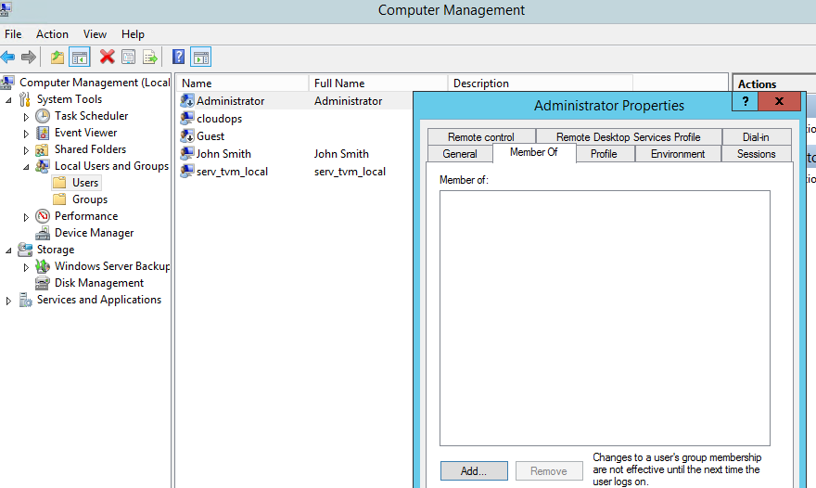

- Install OMS Agent in Windows
Before installing the Microsoft Monitoring Agent for Windows, you need the workspace ID and key for your Log Analytics workspace. This information is required during setup from each installation method to properly configure the agent and ensure it can successfully communicate with Log Analytics in Azure.
- In the Azure portal, click All services. In the list of resources, type Log Analytics. As you begin typing, the list filters based on your input. Select Log Analytics.
- In your list of Log Analytics workspaces, select the workspace you intend on configuring the agent to report to.
- Select Advanced settings.
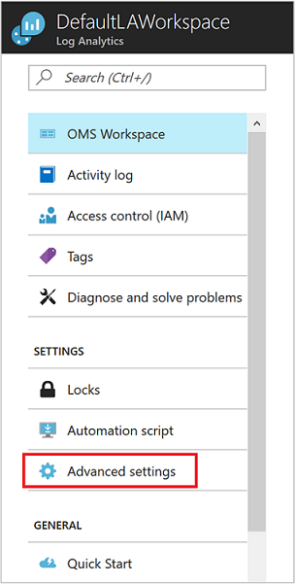
- Select Connected Sources, and then select Windows Servers.
- Copy and paste into your favourite editor, the Workspace ID and Primary Key.

Install the agent using the setup wizard
- In your Log Analytics workspace, from the Windows Servers page, you navigated to earlier, select the appropriate Download Windows Agent version to download depending on the processor architecture of the Windows operating system.
- Run Setup to install the agent on your computer.
- On the Welcome page, click Next.
- On the License Terms page, read the license and then click I Agree.
- On the Destination Folder page, change or keep the default installation folder and then click Next.
- On the Agent Setup Options page, choose to connect the agent to Azure Log Analytics (OMS) and then click Next.
- On the Azure Log Analytics page, perform the following:
  - Paste the Workspace ID and Workspace Key (Primary Key) that you copied earlier. If the computer should report to a Log Analytics workspace in the Azure Government cloud, select Azure US Government from the Azure Cloud drop-down list.
- Click Next once you have completed providing the necessary configuration settings.
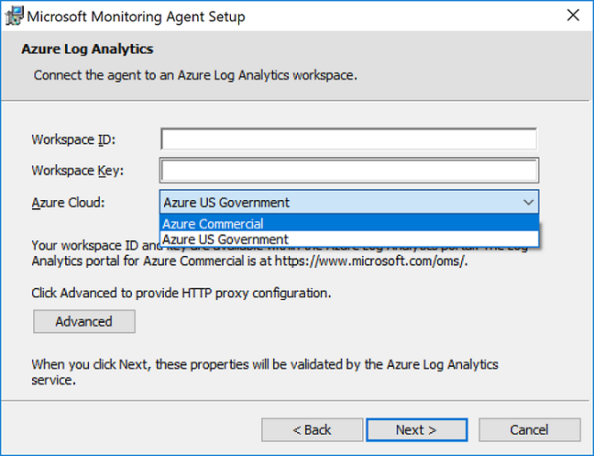
- On the Ready to Install page, review your choices and then click Install.
- On the Configuration completed successfully page, click Finish.

- Disable windows update services
Go to run type “ Services.msc” and disable windows update services
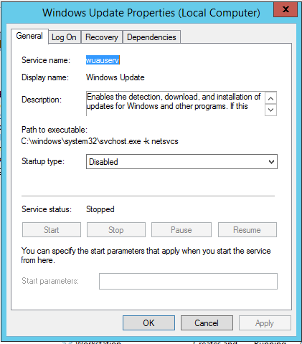

- Set Windows configurations for Azure
On the VM that you plan to upload to Azure, run all commands in the following steps from an elevated Command Prompt window:
- Remove any static persistent route on the routing table:
  - To view the route table, run route print at the command prompt.
  - Check the Persistence Routes sections. If there is a persistent route, use route delete to remove it.
- Remove the WinHTTP proxy:
PowerShellCopy
netsh winhttp reset proxy
- Set the disk SAN policy to Onlineall.
PowerShellCopy
diskpart
In the open Command Prompt window, type the following commands:
DISKPARTCopy
san policy=onlineall
exit
- Set Coordinated Universal Time (UTC) time for Windows and the startup type of the Windows Time (w32time) service to Automatically:
PowerShellCopy
Set-ItemProperty -Path 'HKLM:\SYSTEM\CurrentControlSet\Control\TimeZoneInformation' -name "RealTimeIsUniversal" 1 -Type DWord

Set-Service -Name w32time -StartupType Auto
- Set the power profile to the High Performance:
PowerShellCopy
powercfg /setactive SCHEME_MIN

Check the Windows services
Make sure that each of the following Windows services is set to the Windows default values. These are the minimum numbers of services that must be set up to make sure that the VM has connectivity. To reset the startup settings, run the following commands:
PowerShellCopy
Set-Service -Name bfe -StartupType Auto
Set-Service -Name dhcp -StartupType Auto
Set-Service -Name dnscache -StartupType Auto
Set-Service -Name IKEEXT -StartupType Auto
Set-Service -Name iphlpsvc -StartupType Auto
Set-Service -Name netlogon -StartupType Manual
Set-Service -Name netman -StartupType Manual
Set-Service -Name nsi -StartupType Auto
Set-Service -Name termService -StartupType Manual
Set-Service -Name MpsSvc -StartupType Auto
Set-Service -Name RemoteRegistry -StartupType Auto

Update Remote Desktop registry settings
Make sure that the following settings are configured correctly for remote desktop connection:
Note
You may receive an error message when you run the Set-ItemProperty -Path 'HKLM:\SOFTWARE\Policies\Microsoft\Windows NT\Terminal Services -name <object name> <value> in these steps. The error message can be safely ignored. It means only that the domain is not pushing that configuration through a Group Policy object.
- Remote Desktop Protocol (RDP) is enabled:
PowerShellCopy
Set-ItemProperty -Path 'HKLM:\SYSTEM\CurrentControlSet\Control\Terminal Server' -name "fDenyTSConnections" -Value 0 -Type DWord

Set-ItemProperty -Path 'HKLM:\SOFTWARE\Policies\Microsoft\Windows NT\Terminal Services' -name "fDenyTSConnections" -Value 0 -Type DWord
- The RDP port is set up correctly (Default port 3389):
PowerShellCopy
Set-ItemProperty -Path 'HKLM:\SYSTEM\CurrentControlSet\Control\Terminal Server\Winstations\RDP-Tcp' -name "PortNumber" 3389 -Type DWord
When you deploy a VM, the default rules are created against port 3389. If you want to change the port number, do that after the VM is deployed in Azure.
- The listener is listening in every network interface:
PowerShellCopy
Set-ItemProperty -Path 'HKLM:\SYSTEM\CurrentControlSet\Control\Terminal Server\Winstations\RDP-Tcp' -name "LanAdapter" 0 -Type DWord
- Configure the Network Level Authentication mode for the RDP connections:
PowerShellCopy
Set-ItemProperty -Path 'HKLM:\SYSTEM\CurrentControlSet\Control\Terminal Server\WinStations\RDP-Tcp' -name "UserAuthentication" 1 -Type DWord

Set-ItemProperty -Path 'HKLM:\SYSTEM\CurrentControlSet\Control\Terminal Server\WinStations\RDP-Tcp' -name "SecurityLayer" 1 -Type DWord

Set-ItemProperty -Path 'HKLM:\SYSTEM\CurrentControlSet\Control\Terminal Server\WinStations\RDP-Tcp' -name "fAllowSecProtocolNegotiation" 1 -Type DWord
- Set the keep-alive value：
PowerShellCopy
Set-ItemProperty -Path 'HKLM:\SOFTWARE\Policies\Microsoft\Windows NT\Terminal Services' -name "KeepAliveEnable" 1 -Type DWord
Set-ItemProperty -Path 'HKLM:\SOFTWARE\Policies\Microsoft\Windows NT\Terminal Services' -name "KeepAliveInterval" 1 -Type DWord
Set-ItemProperty -Path 'HKLM:\SYSTEM\CurrentControlSet\Control\Terminal Server\Winstations\RDP-Tcp' -name "KeepAliveTimeout" 1 -Type DWord
- Reconnect：
PowerShellCopy
Set-ItemProperty -Path 'HKLM:\SOFTWARE\Policies\Microsoft\Windows NT\Terminal Services' -name "fDisableAutoReconnect" 0 -Type DWord
Set-ItemProperty -Path 'HKLM:\SYSTEM\CurrentControlSet\Control\Terminal Server\Winstations\RDP-Tcp' -name "fInheritReconnectSame" 1 -Type DWord
Set-ItemProperty -Path 'HKLM:\SYSTEM\CurrentControlSet\Control\Terminal Server\Winstations\RDP-Tcp' -name "fReconnectSame" 0 -Type DWord
- Limit the number of concurrent connections：
PowerShellCopy
Set-ItemProperty -Path 'HKLM:\SYSTEM\CurrentControlSet\Control\Terminal Server\Winstations\RDP-Tcp' -name "MaxInstanceCount" 4294967295 -Type DWord
- If there are any self-signed certificates tied to the RDP listener, remove them:
PowerShellCopy
Remove-ItemProperty -Path 'HKLM:\SYSTEM\CurrentControlSet\Control\Terminal Server\WinStations\RDP-Tcp' -name "SSLCertificateSHA1Hash"
This is to make sure that you can connect at the beginning when you deploy the VM. You can also review this on a later stage after the VM is deployed in Azure if needed.
- If the VM will be part of a Domain, check all the following settings to make sure that the former settings are not reverted. The policies that must be checked are the following:
  - RDP is enabled:
Computer Configuration\Policies\Windows Settings\Administrative Templates\ Components\Remote Desktop Services\Remote Desktop Session Host\Connections:
Allow users to connect remotely by using Remote Desktop
  - NLA group policy:
Settings\Administrative Templates\Components\Remote Desktop Services\Remote Desktop Session Host\Security:
Require user Authentication for remote connections by using Network Level Authentication
  - Keep Alive settings:
Computer Configuration\Policies\Windows Settings\Administrative Templates\Windows Components\Remote Desktop Services\Remote Desktop Session Host\Connections:
Configure keep-alive connection interval
  - Reconnect settings:
Computer Configuration\Policies\Windows Settings\Administrative Templates\Windows Components\Remote Desktop Services\Remote Desktop Session Host\Connections:
Automatic reconnection
  - Limit the number of connections settings:
Computer Configuration\Policies\Windows Settings\Administrative Templates\Windows Components\Remote Desktop Services\Remote Desktop Session Host\Connections:
Limit number of connections

Configure Windows Firewall rules
- Turn on Windows Firewall on the three profiles (Domain, Standard, and Public):
PowerShellCopy
Set-ItemProperty -Path 'HKLM:\SYSTEM\CurrentControlSet\services\SharedAccess\Parameters\FirewallPolicy\DomainProfile' -name "EnableFirewall" -Value 1 -Type DWord
Set-ItemProperty -Path 'HKLM:\SYSTEM\CurrentControlSet\services\SharedAccess\Parameters\FirewallPolicy\PublicProfile' -name "EnableFirewall" -Value 1 -Type DWord
Set-ItemProperty -Path 'HKLM:\SYSTEM\CurrentControlSet\services\SharedAccess\Parameters\FirewallPolicy\Standardprofile' -name "EnableFirewall" -Value 1 -Type DWord
- Run the following command in PowerShell to allow WinRM through the three firewall profiles (Domain, Private, and Public) and enable the PowerShell Remote service:
PowerShellCopy
Enable-PSRemoting -force
netsh advfirewall firewall set rule dir=in name="Windows Remote Management (HTTP-In)" new enable=yes
netsh advfirewall firewall set rule dir=in name="Windows Remote Management (HTTP-In)" new enable=yes
- Enable the following firewall rules to allow the RDP traffic
PowerShellCopy
netsh advfirewall firewall set rule group="Remote Desktop" new enable=yes
- Enable the File and Printer Sharing rule so that the VM can respond to a ping command inside the Virtual Network:
PowerShellCopy
netsh advfirewall firewall set rule dir=in name="File and Printer Sharing (Echo Request - ICMPv4-In)" new enable=yes
- If the VM will be part of a Domain, check the following settings to make sure that the former settings are not reverted. The AD policies that must be checked are the following:
  - Enable the Windows Firewall profiles
Computer Configuration\Policies\Windows Settings\Administrative Templates\Network\Network Connection\Windows Firewall\Domain Profile\Windows Firewall: Protect all network connections
Computer Configuration\Policies\Windows Settings\Administrative Templates\Network\Network Connection\Windows Firewall\Standard Profile\Windows Firewall: Protect all network connections
  - Enable RDP
Computer Configuration\Policies\Windows Settings\Administrative Templates\Network\Network Connection\Windows Firewall\Domain Profile\Windows Firewall: Allow inbound Remote Desktop exceptions
Computer Configuration\Policies\Windows Settings\Administrative Templates\Network\Network Connection\Windows Firewall\Standard Profile\Windows Firewall: Allow inbound Remote Desktop exceptions
  - Enable ICMP-V4
Computer Configuration\Policies\Windows Settings\Administrative Templates\Network\Network Connection\Windows Firewall\Domain Profile\Windows Firewall: Allow ICMP exceptions
Computer Configuration\Policies\Windows Settings\Administrative Templates\Network\Network Connection\Windows Firewall\Standard Profile\Windows Firewall: Allow ICMP exceptions

Verify VM is healthy, secure, and accessible with RDP
- To make sure the disk is healthy and consistent, run a check disk operation at the next VM restart:
PowerShellCopy
Chkdsk /f
Make sure that the report shows a clean and healthy disk.
- Set the Boot Configuration Data (BCD) settings.
Note
Make sure you run these commands on an elevated CMD window and NOT on PowerShell:
CMDCopy
bcdedit /set {bootmgr} integrityservices enable

bcdedit /set {default} device partition=C:

bcdedit /set {default} integrityservices enable

bcdedit /set {default} recoveryenabled Off

bcdedit /set {default} osdevice partition=C:

bcdedit /set {default} bootstatuspolicy IgnoreAllFailures
- Verify that the Windows Management Instrumentations repository is consistent. To perform this, run the following command:
PowerShellCopy
winmgmt /verifyrepository
If the repository is corrupted, see WMI: Repository Corruption, or Not.
- Make sure that any other application is not using the port 3389. This port is used for the RDP service in Azure. You can run netstat -anob to see which ports are in used on the VM:
PowerShellCopy
netstat -anob

Complete recommended configurations
The following settings do not affect VHD uploading. However, we strongly recommend that you configured them.
- Install the Azure VMs Agent. Then you can enable VM extensions. The VM extensions implement most of the critical functionality that you might want to use with your VMs such as resetting passwords, configuring RDP, and so on. For more information, see:
  - VM Agent and Extensions – Part 1
  - VM Agent and Extensions – Part 2
- The Dump log can be helpful in troubleshooting Windows crash issues. Enable the Dump log collection:
PowerShellCopy
Set-ItemProperty -Path 'HKLM:\SYSTEM\CurrentControlSet\Control\CrashControl' -name "CrashDumpEnable" -Value "2" -Type DWord
Set-ItemProperty -Path 'HKLM:\SYSTEM\CurrentControlSet\Control\CrashControl' -name "DumpFile" -Value "%SystemRoot%\MEMORY.DMP"
Set-ItemProperty -Path 'HKLM:\SYSTEM\CurrentControlSet\Control\CrashControl' -name "AutoReboot" -Value 0 -Type DWord
New-Item -Path 'HKLM:\SOFTWARE\Microsoft\Windows\Windows Error Reporting\LocalDumps'
New-ItemProperty -Path 'HKLM:\SOFTWARE\Microsoft\Windows\Windows Error Reporting\LocalDumps' -name "DumpFolder" -Value "c:\CrashDumps"
New-ItemProperty -Path 'HKLM:\SOFTWARE\Microsoft\Windows\Windows Error Reporting\LocalDumps' -name "DumpCount" -Value 10 -Type DWord
New-ItemProperty -Path 'HKLM:\SOFTWARE\Microsoft\Windows\Windows Error Reporting\LocalDumps' -name "DumpType" -Value 2 -Type DWord
Set-Service -Name WerSvc -StartupType Manual
If you receive any errors during any of the procedural steps in this article, this means that the registry keys already exists. In this situation, use the following commands instead:
PowerShellCopy
Set-ItemProperty -Path 'HKLM:\SYSTEM\CurrentControlSet\Control\CrashControl' -name "CrashDumpEnable" -Value "2" -Type DWord
Set-ItemProperty -Path 'HKLM:\SYSTEM\CurrentControlSet\Control\CrashControl' -name "DumpFile" -Value "%SystemRoot%\MEMORY.DMP"
Set-ItemProperty -Path 'HKLM:\SOFTWARE\Microsoft\Windows\Windows Error Reporting\LocalDumps' -name "DumpFolder" -Value "c:\CrashDumps"
Set-ItemProperty -Path 'HKLM:\SOFTWARE\Microsoft\Windows\Windows Error Reporting\LocalDumps' -name "DumpCount" -Value 10 -Type DWord
Set-ItemProperty -Path 'HKLM:\SOFTWARE\Microsoft\Windows\Windows Error Reporting\LocalDumps' -name "DumpType" -Value 2 -Type DWord
Set-Service -Name WerSvc -StartupType Manual

Reference: https://docs.microsoft.com/en-us/azure/virtual-machines/windows/prepare-for-upload-vhd-image

- Sysprep Windows Server 2012 R2
Log in to the Windows VM.
- Run Command Prompt as an administrator.
- Change the directory to: %windir%\system32\sysprep, and then run sysprep.exe.
- In the System Preparation Tool dialog box, select Enter System Out-of-Box Experience (OOBE), and make sure that the Generalize check box is selected.
- 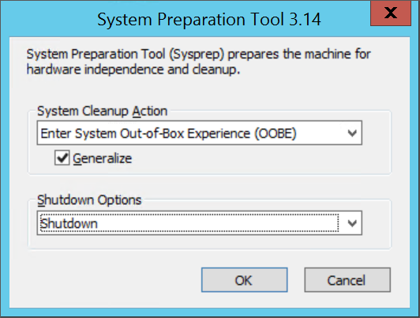
- In Shutdown Options, select Shutdown.
- Click OK.
When Sysprep completes, shut down the VM. Do not use Restart to shut down the VM. Now the VHD is ready to be uploaded.

- Convert VMDK to VHD
Once VM is prepared and ready now it’s a time to convert the vmdk file to vhd file with fixed disk size.

Step 1 – Installing Microsoft Virtual Machine Converter
To convert the VMDK to VHD we need a conversion kit from Microsoft. With the Conversion Kit you can convert a Virtual Machines and Disk from VMWare to Hyper-V. The catch here is that the Conversion kit needs to connect to the VMware and Hyper-V host.
That is not always an option, but kit also comes with a PowerShell module that includes the capabilities for offline conversion. And that is exactly what we are going to use.
So download the and install the Conversion Kit.

Step 2 – Import the Powershell Module
After you installed the Microsoft Conversion Kit, start PowerShell and import the following module:
Import-Module "C:\Program Files\Microsoft Virtual Machine Converter\MvmcCmdlet.psd1"
Step 3 – Convert VMDK to VHD
When the module is imported we can convert the disks with the following cmdlet:
PS C:\> ConvertTo-MvmcVirtualHardDisk -SourceLiteralPath E:\ws2012r2.vmdk -Destination E:\VHD\ws2012r2.vhd -VhdType FixedHardDisk -VhdFormat vhd

- Upload VHD to the storage account
You can upload a VHD to your storage account using one of the following:
AzCopy
Azure Portal + Resource Group + Storage Account + Storage Explorer + Upload file or folder
Azure Storage Explorer Uploading Blobs
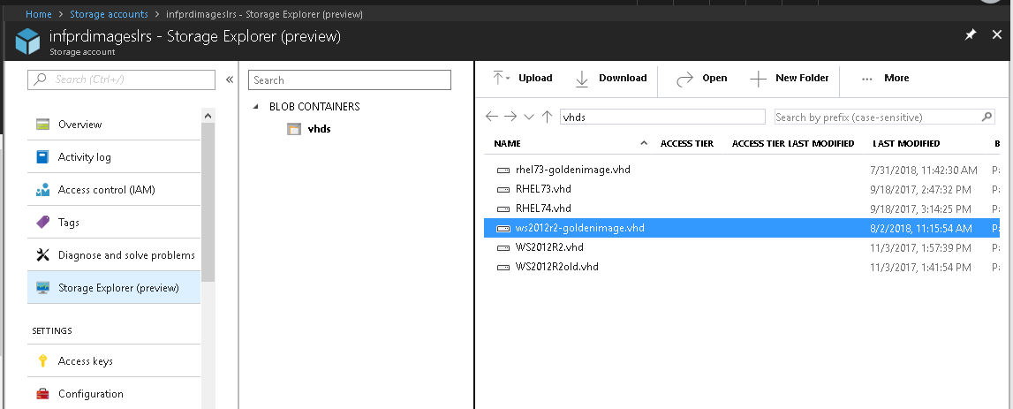

- Create an image and add vhd file to images
Create a managed image from a generalized OS VHD in a storage account. You need the URI of the VHD in the storage account, which is in the format https://mystorageaccount.blob.core.windows.net/container/vhd_filename.vhd
Create an image using the Azure Portal.
- In the Azure Portal, select Images.
- Click Add to create a new image.
- Give the image a name. Remember that this image is a template that will later be deployed to a virtual machine with a different name.
- Ensure that the location is the same as the location of your storage account.
- Select OS disk Premium and OS type Windows.
- Click Browse on the Storage Blob field. A new panel will list your storage accounts. Using this panel, navigate through the storage account and container to locate the Window Server 2012 R2 Golden Image VHD that was uploaded.
- Click Create to begin the image creation process. This process typically takes minutes to complete.
When the process has completed, return to the Images panel and verify that the new image was created.
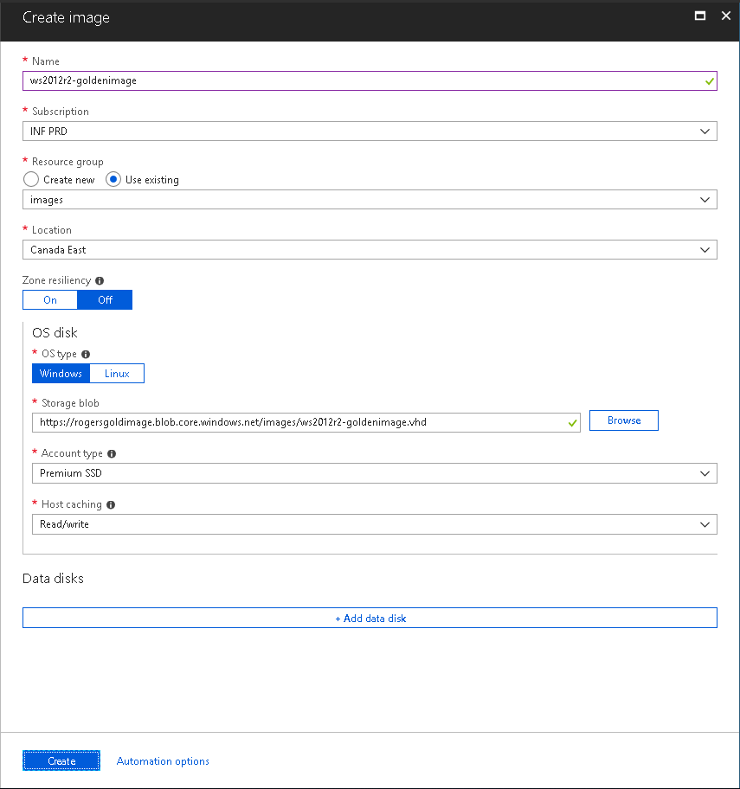
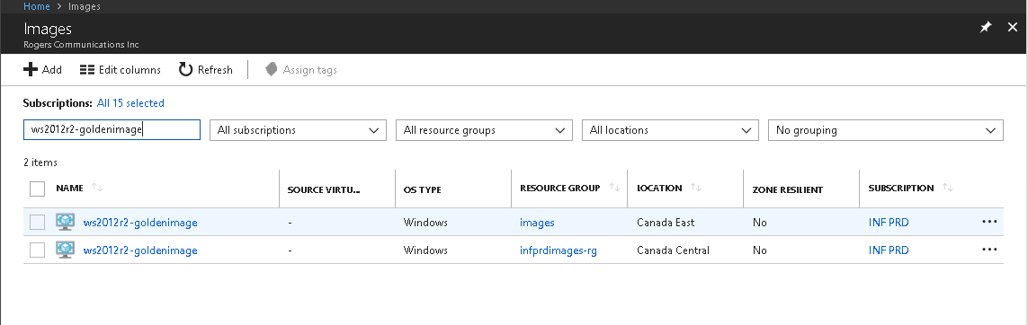

- Create a VM from a Golden Image
Use the portal
- Open the Azure portal.
- In the left menu, select All resources. You can sort the resources by Type to easily find your images.
- Select the image you want to use from the list. The image Overview page opens.
- Click + Create VM from the menu.
- Enter the virtual machine information. The username and password entered here is used to log in to the virtual machine. When complete, click OK. You can create the new VM in an existing Resource Group to store the VM.
- Select a size for the VM. To see more sizes, select View all or change the Supported disk type filter.
- Under Settings, make changes as necessary and click OK.

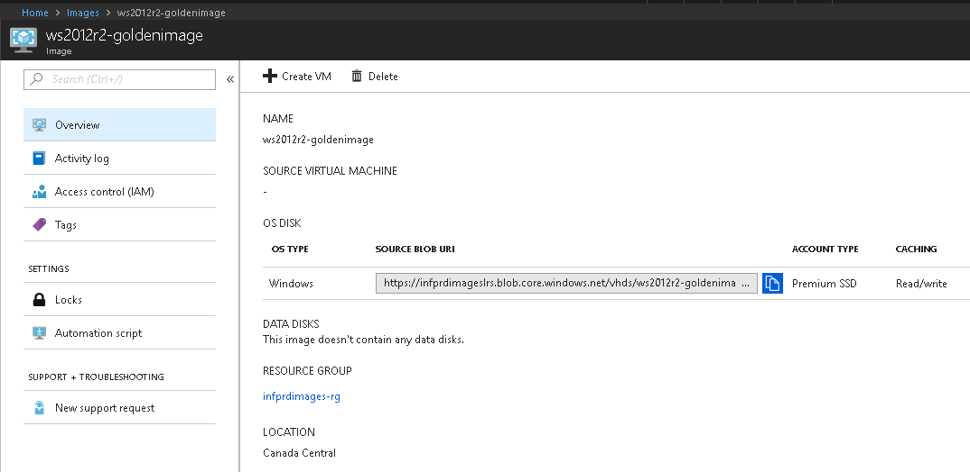

Migrating With Microsoft ASR
The recommended method of migrating virtual machines to Azure is to use ASR. Using ASR, organizations can replicate their on-premises Hyper-V virtual machines, physical servers and VMware virtual machines to Azure. This is useful for disaster recovery to perform failovers, and also to migrate from an on-premises environment to Azure.

QC / Validation:

Escalation Matrix:

